|  |
| --- |
| Microsoft SharePoint 2013 - Hands-on Lab |
| Web Content Management |
| Verified Against Build #15.0.4420.1017 |

|  |
| --- |
| Microsoft  Version 1.0  August 14, 2012 |

Information in this document, including URL and other Internet Web site references, is subject to change without notice. Unless otherwise noted, the example companies, organizations, products, domain names, e-mail addresses, logos, people, places, and events depicted herein are fictitious, and no association with any real company, organization, product, domain name, e-mail address, logo, person, place, or event is intended or should be inferred. Complying with all applicable copyright laws is the responsibility of the user. Without limiting the rights under copyright, no part of this document may be reproduced, stored in or introduced into a retrieval system, or transmitted in any form or by any means (electronic, mechanical, photocopying, recording, or otherwise), or for any purpose, without the express written permission of Microsoft Corporation.

The names of manufacturers, products, or URLs are provided for informational purposes only and Microsoft makes no representations and warranties, either expressed, implied, or statutory, regarding these manufacturers or the use of the products with any Microsoft technologies. The inclusion of a manufacturer or product does not imply endorsement of Microsoft of the manufacturer or product. Links are provided to third party sites. Such sites are not under the control of Microsoft and Microsoft is not responsible for the contents of any linked site or any link contained in a linked site, or any changes or updates to such sites. Microsoft is not responsible for webcasting or any other form of transmission received from any linked site. Microsoft is providing these links to you only as a convenience, and the inclusion of any link does not imply endorsement of Microsoft of the site or the products contained therein.

Microsoft may have patents, patent applications, trademarks, copyrights, or other intellectual property rights covering subject matter in this document. Except as expressly provided in any written license agreement from Microsoft, the furnishing of this document does not give you any license to these patents, trademarks, copyrights, or other intellectual property.

Copyright © 2012 Microsoft Corporation. All rights reserved.

Microsoft and SharePoint are either registered trademarks or trademarks of Microsoft Corporation in the United States and/or other countries.

The names of actual companies and products mentioned herein may be the trademarks of their respective owners.

# Technical Background

This section is intended for labs with technical background information that would be of interest to lab consumers.

## Introduction

SharePoint 2013 represents a major shift in the architecture for Web Content Management, SharePoint 2013’s capability of hosting content-centric sites.

## Create Lab SharePoint Site Collection

This lab assumes you have a Web application created at <http://intranet.contoso.com>. If you do not already have that, create that now.

In the files provided with the hands on lab, run the batch file called **SetupModule.bat** by double clicking it. This file will execute a PowerShell script that will create two new site collections at <http://intranet.contoso.com> and <http://intranet.contoso.com/sites/wcm>.

|  |
| --- |
| Description: C:\Users\vesaj\Pictures\DVD_ART36\Artwork_Imagery\Icons - Illustrations\_ SUPER VISTA STYLE\yield sign red white exclamation point.png **Important** |
| *It is important you run this batch file to create the site collection before working through any of the exercises as the exercises contain instructions for working with this specific site collection at the specific URL created by the script.* |

The script will first check to see if there is already a site collection at the specified addresses. If there are it will delete the site collections before creating it. Therefore if you run into problems with the lab, feel free to rerun the batch file to reset the environment and restart the exercise.

# Introduction

## Estimated time to complete this lab

60 minutes

## Objectives

After completing this lab, you will be able to:

Setup a taxonomy, content catalog and site with sample content

Publishing & connecting to a content catalog

Configuring a site for managed navigation

Implementing a custom brand

## Computers in this lab

This lab uses virtual machines as described in the following table. Before you begin the lab, you must start the virtual machines and then log on to the computers.

|  |  |
| --- | --- |
| **Virtual Machine** | **Role** |
| {Supplied by Instructor} | Domain Controller |
| {Supplied by Instructor} | Actual SharePoint environment with Office client and other required software. |

All user accounts in this lab use the password {Supplied by Instructor}.

## Lab Setup Script

This lab assumes you have a Web application created at <http://intranet.contoso.com>. If you do not already have that, create that now.

In the files provided with the hands on lab, run the batch file called **SetupModule.bat** by double clicking it. This file will execute a PowerShell script that will create two new site collections at <http://intranet.contoso.com> and <http://intranet.contoso.com/sites/wcm>.

|  |
| --- |
| Description: C:\Users\vesaj\Pictures\DVD_ART36\Artwork_Imagery\Icons - Illustrations\_ SUPER VISTA STYLE\yield sign red white exclamation point.png **Important** |
| *It is important you run this batch file to create the site collection before working through any of the exercises as the exercises contain instructions for working with this specific site collection at the specific URL created by the script.* |

The script will first check to see if there is already a site collection at the specified address. If there is it will delete the site collection before creating it. Therefore if you run into problems with the lab, feel free to rerun the batch file to reset the environment and restart the exercise.

# Exercise 1: Setup Content Catalog, Taxonomy and Configure Search

In this exercise you will run a utility that will create a new site collection based on the Publishing Portal site collection and create a new catalog list with sample data and taxonomy to use for classifying the content. Finally you’ll configure search to index the content & create a few managed properties.

## Task 1: Create Product Catalog & Taxonomy

In this task you will run a utility that will create a new Catalog list in a site collection, fill it with sample data and create a taxonomy that will be used by this catalog.

Begin this task logged on to **SP** as **CONTOSO\Administrator**.

1. Ensure the Managed Metadata Service Application is configured for the lab.
   * Open **Central Administration** and navigate to Application Management / Manage Service Applications.
   * Click the Managed Metadata Service Application proxy (the second one in the list) and choose **Properties**.
   * Make sure that **This service application is the default storage location for Keywords** and **This service application is the default storage location for column specific term sets** are both **checked.**
2. In the files supplied with this lab you will find a subfolder **SiteSetup**. Open a command prompt (**Start 🡪 Accessories 🡪 Command Prompt**) and change directory to this folder.
3. Run the executable file, **SharePointImport.exe**, by typing it in and pressing **ENTER**.
4. While the import utility runs you will see it display its progress. The job of the importer is to create a new site collection & sample data used in the site throughout this lab. In addition it will create a taxonomy used for searching and navigating the content in the list.
5. When the import utility completes, close the command prompt.

## Task 2: Verify Product Catalog & Taxonomy Created

In this task you will verify that the product catalog and taxonomy were properly created in your environment.

Begin this task logged on to **SP** as **CONTOSO\Administrator**.

1. After running the import utility, you need to verify all the correct content has been created.
2. Open the browser and navigate to the following site: <http://intranet.contoso.com/sites/ProductCatalog>.
3. Verify there is a list called **ContosoProducts** using the **Site Contents** link in the **Quick Launch** navigation and selecting the **ContosoProducts** app. This list should contain some data:

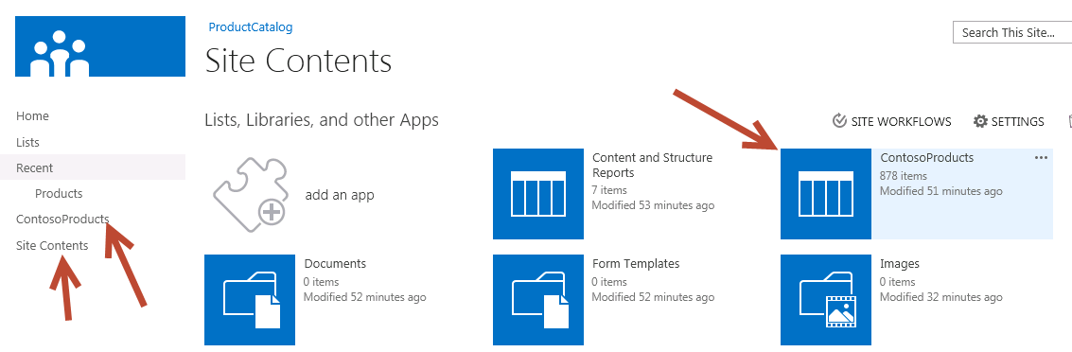

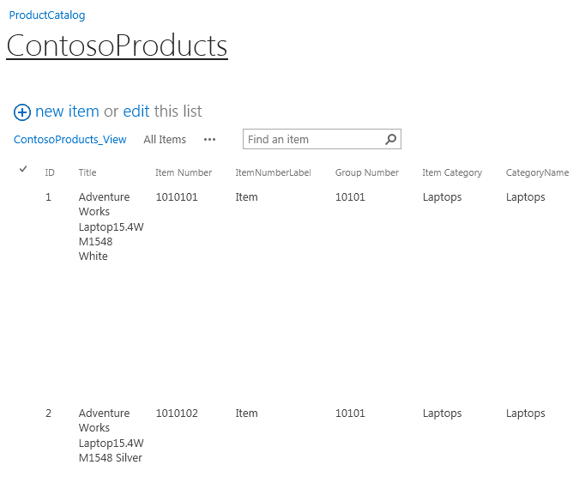

1. Next, ensure the taxonomy was created for the ContosoProducts catalog. Select the gear in the top-right corner of the site and select **Site Settings**.

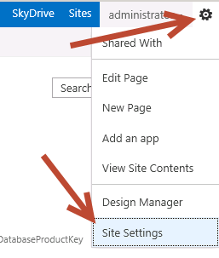

1. On the **Site Settings** page, under the **Site Administration** section, select **Term Store Management**.
2. Verify that a term set called **Product Hierarchy** in the current site collection is present using the **Term Store Management Tool**:

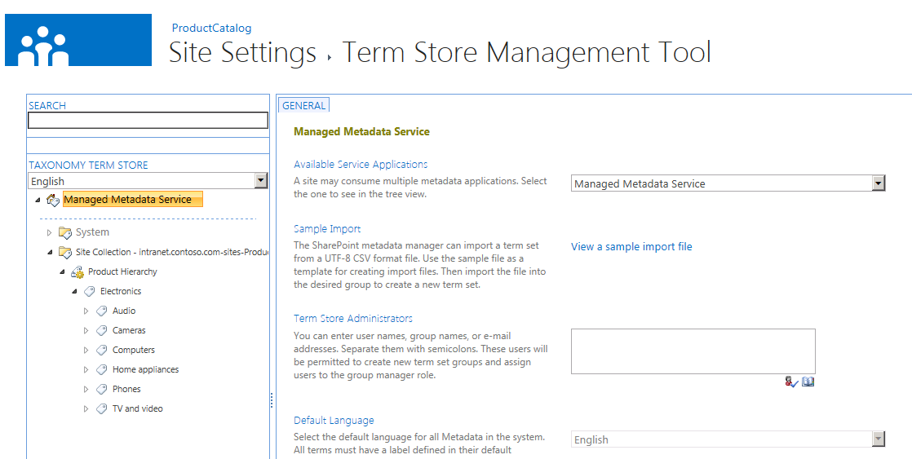

## Task 3: Configure Search & Managed Properties

In this task you will configure the search service application and create a few managed properties that will be used in a later exercise.

Begin this task logged on to **SP** as **CONTOSO\Administrator**.

1. Navigate to Central Administration by selecting **Start 🡪 All Programs 🡪 Microsoft SharePoint 2013 Products → SharePoint 2013 Central Administration**.
2. Under the **Application Management**, select **Manage Service Applications**.
3. Select the service application **Search Service Application**.
4. Before creating managed properties you need to make the search service application aware of all content properties. To do this, you must crawl the content. Start a full crawl of the ContosoProducts catalog:
   * Select **Content Sources** in the left-hand list of links on the **Search Service Application: Search Administration** page.
   * Select the **Local SharePoint Sites** content source and pick **Start Full Crawl**.

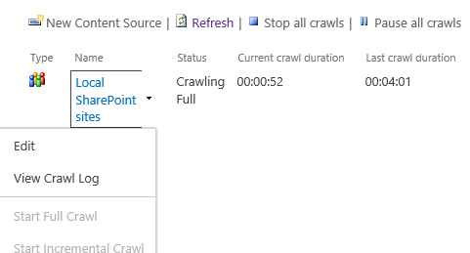

Note that this step may vary depending on environment. You will want to verify the content source being used contains the <http://intranet.contoso.com> web application before continuing.

* + This step might take 5-10 minutes depending on the performance of the server you are working on. Click the **Refresh** link at the top of the page to monitor the progress of the crawl.
  + When the crawl is finished, proceed to the next step.

1. Once the content has been crawled you can create a few managed properties that will be used to find the content in the catalog. Select the **Search Schema** link in the left-hand navigation.
2. Create a new managed property by clicking the **New Managed Property** link and using the following information to create it (leave the default values for any selections not specified in the following list) and click **OK** at the end:
   * **Property Name:** ItemId
   * **Type:** Text
   * **Searchable:** Checked
   * **Queryable:** Checked
   * **Retrievable:** Checked
   * **Token Normalization:** Checked
   * **Mappings to Crawled Properties:**

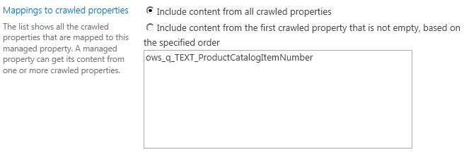

1. Repeat the process to create the following additional managed properties:

|  |  |  |  |
| --- | --- | --- | --- |
| **Property Name** | Category | Price | Color |
| **Type** | Text | Integer | Text |
| **Searchable** | Checked | Checked | Checked |
| **Queryable** | Checked | Checked | Checked |
| **Retrievable** | Checked | Checked | Checked |
| **Token Normalization** | Checked | Checked | Checked |
| **Sortable** | No | Yes – Active | No |
| **Refinable** | Yes – Active | Yes - Active | Yes – Active |
| **Mapping** | ows\_taxId\_ProductCatalogItemCategory | ows\_q\_TEXT\_UnitPrice | ows\_q\_TEXT\_Color |

1. In order to populate the search index with these new managed properties you must re-crawl the content.
   * Select **Content Sources** in the left-hand list of links on the **Search Service Application: Search Administration** page.
   * Select the **Local SharePoint Sites** and pick **Start Full Crawl**.
   * This step might take 5-10 minutes depending on the performance of the server you are working on. Click the **Refresh** link at the top of the page to monitor the progress of the crawl.
   * When the crawl is finished, proceed to the next step.

## Task 4: Verify Search & Managed Properties are Working

In this task you will create a sample search site and run a few queries to ensure the search service application has indexed the content in the catalog list and populated the managed properties.

Begin this task logged on to **SP** as **CONTOSO\Administrator**.

* 1. In Site Settings, go to Site Collection Features and ensure the SharePoint Server Publishing Infrastructure feature is enabled.
  2. Before leveraging the content catalog and search configuration changes in a Publishing site it is recommended you test the contents of the index. Do this by creating a new search site. Navigate <http://intranet.contoso.com>.
  3. Select the Site Contents link in the Quick Launch navigation.
  4. On the Lists, Libraries, and other Apps page, under the Subsites section, select the new subsite link.
  5. Use the following image to fill in the details in creating a new search site:

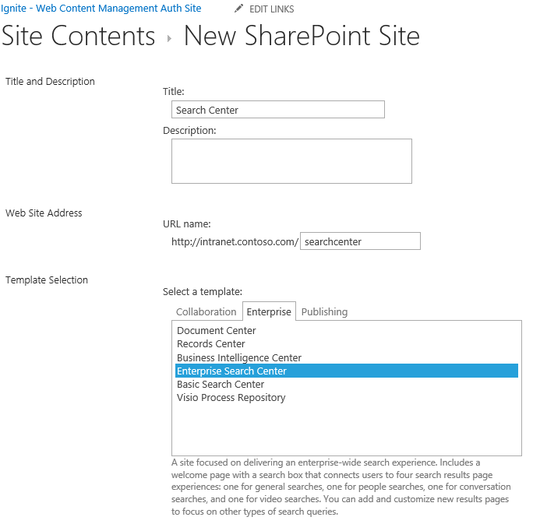

After the site is created you will be redirected to the search page. Try a basic keyword search by entering **camera** and press **ENTER** as a search term. You should see the following (or similar) results:

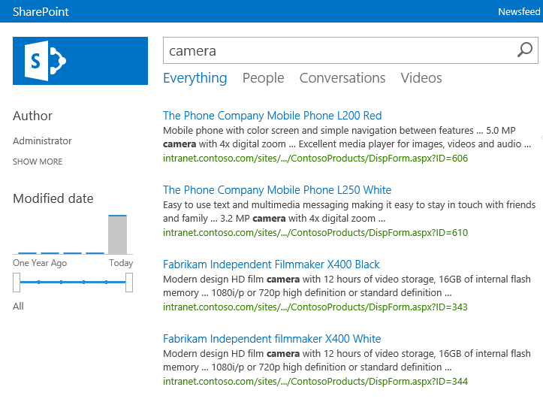

Next try a search using the managed properties you previously created by entering a search term such as **category:laptops**

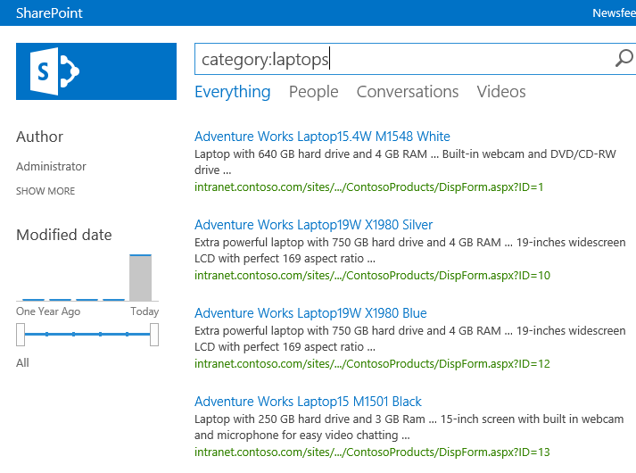

Now search for **color:white**:

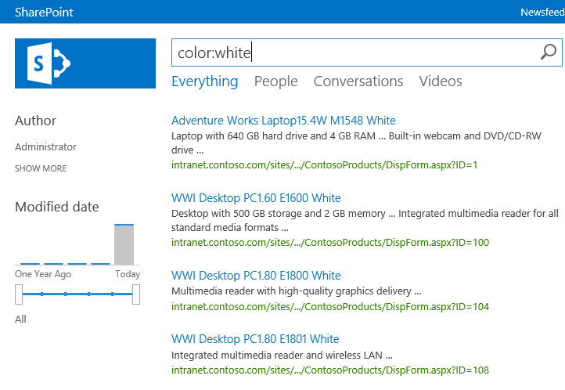

Now search for **itemid:1010101:**

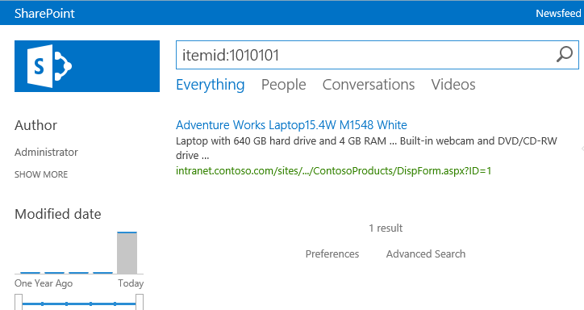

# Exercise 2: Create and Populate the Publishing Site with Content

In this exercise you will first create a new page manually using the structured authoring method. Next you will configure the content catalog created in the previous exercise for sharing with other site collections. You will then connect it to the Publishing site and enable managed navigation on the Publishing site.

## Task 1: Create Content as Structured Authoring

In this task you will create a new page using the new 🡪 page style of content creation (aka: structured authoring) that existing in previous versions of SharePoint and see how pages are added to the navigation automatically.

Begin this task logged on to **SP** as **CONTOSO\Administrator**.

1. Open Internet Explorer and navigate to the Publishing site at <http://intranet.contoso.com/sites/wcm>.
2. First add an image to the site to use in a new page:
   * In the **Quick Launch** navigation, click the **Site Contents** link.
   * On the **Site Contents** page, select the **Images** library.
   * Open Windows Explorer (**Start 🡪 All Programs 🡪 Accessories 🡪 Windows Explorer**) and navigate to the location where the files for this demo are stored.
   * Within this folder you’ll find two images in the **Assets** folder. Select both of these files and drag them into the browser near where it says **Drag files here or click to add an item** under the **Images** library title:

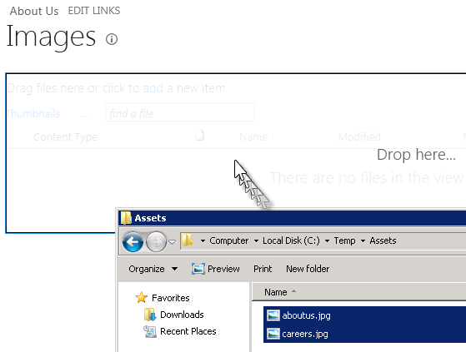

* + After a moment the images will have been uploaded to the library:

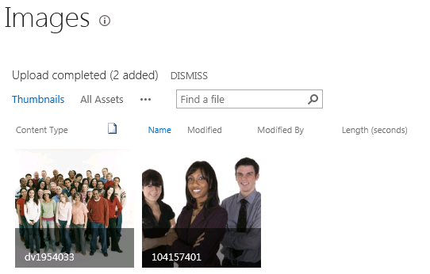

* + After uploading the two images, you need to check them in so they can be used. Do this by selecting the checkbox on each image:

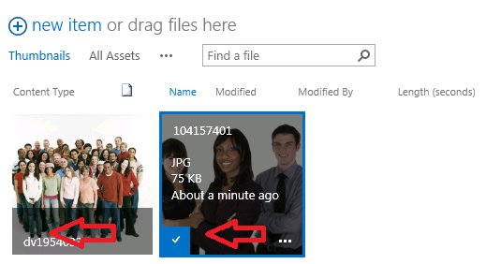

* + Next, select the **Files** tab in the ribbon and click the **Check In** button:

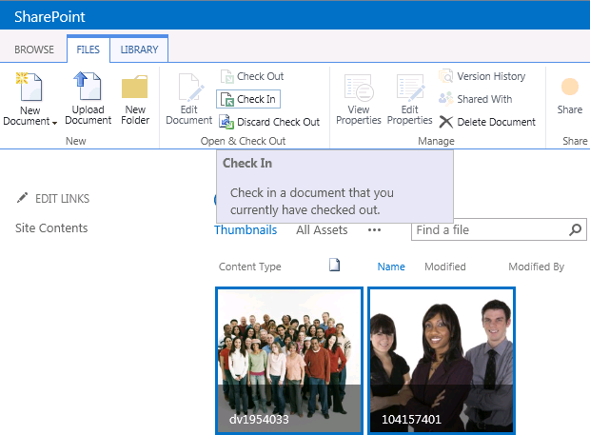

* + When prompted select **Version=Major Version (Publish)** and click **OK**.

1. Next, create a new page using the structured authoring approach in that you will manually create and edit the content on the actual page:
   * Add a new page by clicking the gear in the top-right corner of the page and select **Add a Page**:

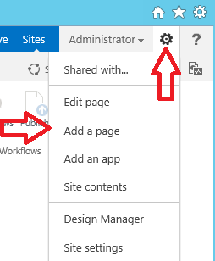

* + In the Add a Page dialog, enter **About Us** and click **Create**.

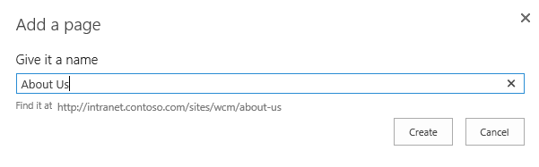

|  |
| --- |
| **C:\Users\vesaj\Pictures\DVD_ART36\Artwork_Imagery\Icons - Illustrations\_ WINDOWS VISTA ICONS\Information more info.png** **Additional Information** |
| *Notice the URL of the page does not include the traditional SharePoint WCM “/Pages” in the URL.* |

* + Enter some text on the page. Use the formatting options under the **Format Text** tab in the ribbon to apply different styles to the text.
  + Add an image to the page by going to the ribbon and selecting the **Insert** tab, then the arrow below the **Picture** button and select **From SharePoint**:

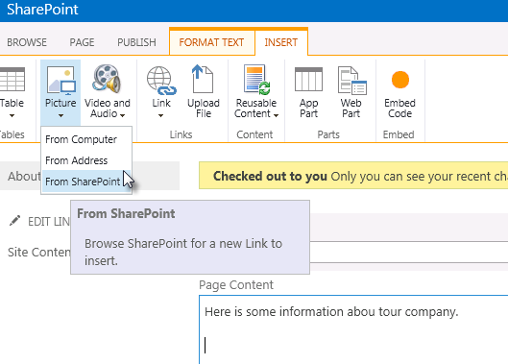

* + Select one of the images you uploaded in a previous step and click **Insert**.

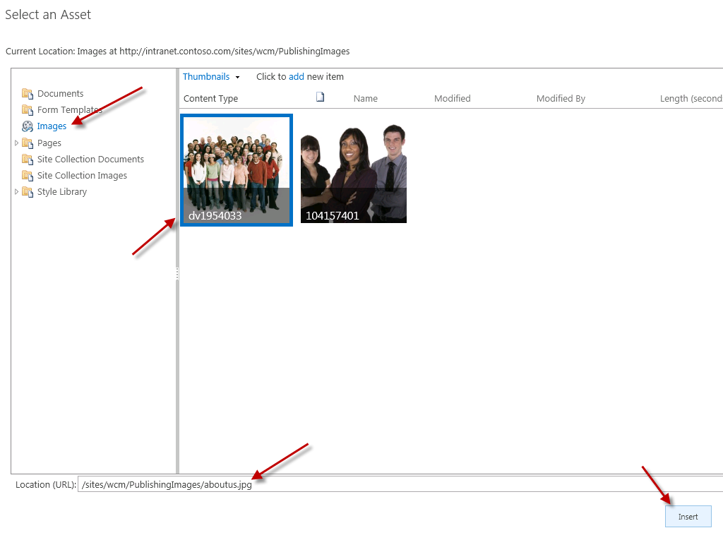

* + Use the picture controls to resize and alter the image.
  + When finished, click the **Check In** button found in the **Page** tab of the ribbon.

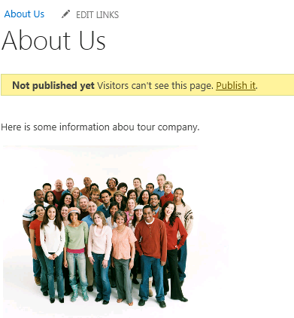

1. Notice how after creating the page the URL is a SEO-friendly URL and the page shows up in the navigation. You can see how the navigation is being created by looking at the site’s navigation taxonomy:
   * Select the gear in the top-right corner of the page and select **Site Settings**.
   * Under the **Site Administration** section, select **Term Store Management**.
   * Expand the term site for the site collection to find the About Us term that is linked to the page you just created:

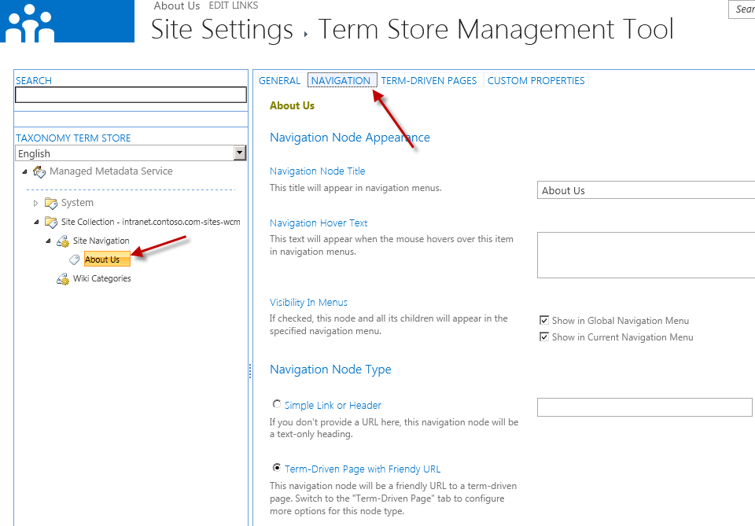

## Task 2: Share the Product Catalog List

In this task you will share the catalog list you created in the previous exercise.

Begin this task logged on to **SP** as **CONTOSO\Administrator**.

1. In order to use the content stored in the ContosoProducts catalog list you must share it so other site collections can connect to it. Using Internet Explorer, navigate to <http://intranet.contoso.com/sites/ProductCatalog>.
2. Select the **Site Conents** link in the **Quick Launch** navigation and select the **ContosoProducts** list.
3. Go to the list’s settings by selecting the **List** tab in the ribbon and then the **List Settings** button.
4. On the List Settings page, select Catalog Settings under the **General Settings** column:

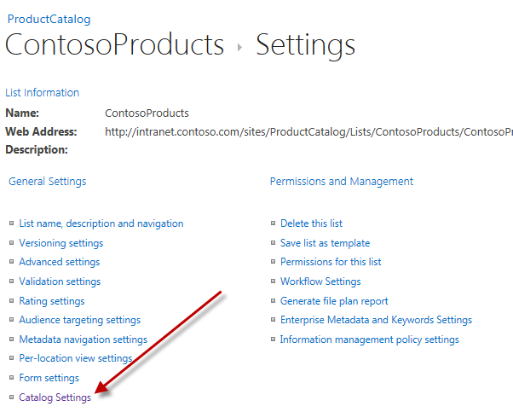

1. On the **Catalog Settings** page, select the following options and click **OK**:
   * **Catalog Sharing:** Checked
   * **Catalog Item URL Fields:** Item Number
   * **Navigation Hierarchy:** Item Category

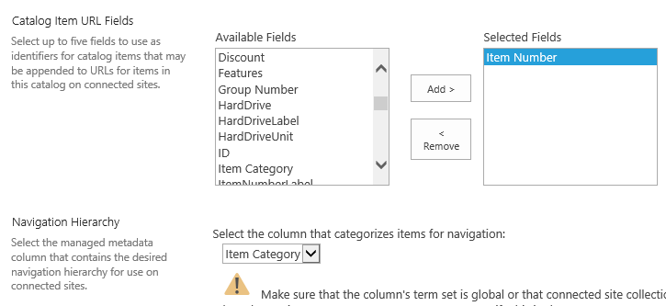

## Task 3: Connect the Catalog to the Publishing Site and Enable Managed Navigation

In this task you will connect the catalog to the Publishing site and configure the managed navigation so the Publishing site’s

Begin this task logged on to **SP** as **CONTOSO\Administrator**.

1. The site collection that contains the ContosoProducts catalog list also contains a term set that should be used for navigation in the Publishing site. In order to use the term set in another site collection it must be shared. Using Internet Explorer, navigate to <http://intranet.contoso.com/sites/ProductCatalog>.
2. Next, use the gear icon in the top-right corner to select the **Site Settings** option.
3. Select the **Term Store Management** option under the **Site Administration** section.
4. Select the Site Collection grouping for the current site collection as shown in the following figure:

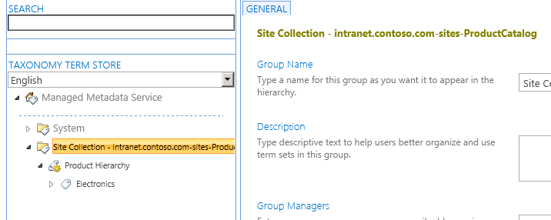

1. Next, enter the URL of the Publishing site collection (<http://intranet.contoso.com/sites/wcm>) to share the term set with in the **Site Collection Access** box and click **Save**:

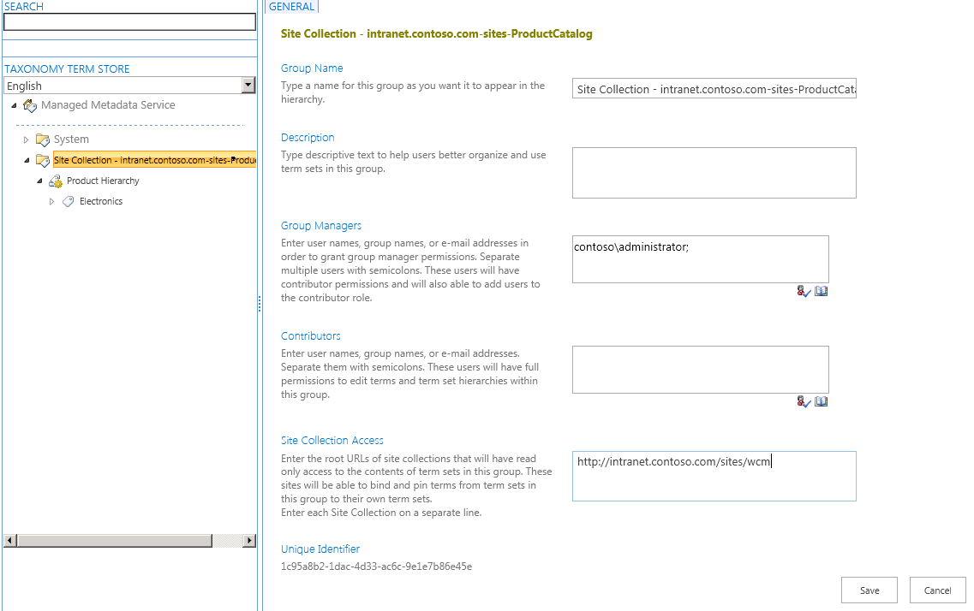

1. Verify the term set is available in the Publishing site. Using Internet Explorer, navigate to <http://intranet.contoso.com/sites/wcm>.
2. Using the gear icon in the top-right corner, go to the **Site Settings** page.
3. Under the **Site Administration** section select **Term Store Management**.
4. Notice that the term set’s site collection is showing up in the Publishing site.

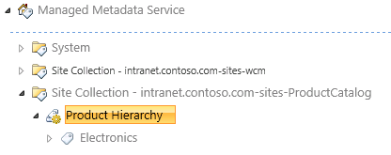

## Task 4: Share the Catalog’s Term Set with the Publishing Site

In this task you will ensure the catalog created in a previous exercise is shared for use in the Publishing site.

Begin this task logged on to **SP** as **CONTOSO\Administrator**.

1. With the ContosoProducts catalog list shared, you now need to connect the Publishing site to the catalog. Using Internet Explorer, navigate to <http://intranet.contoso.com/sites/wcm>.
2. Using the gear icon in the top-right corner, go to the **Site Settings** page.
3. Under the Site Administration section, select **Manage Catalog Connections**.
4. Click the link Connect to a Catalog.
5. The **ContosoProducts** catalog should be listed. Click the **Connect** link on the right:

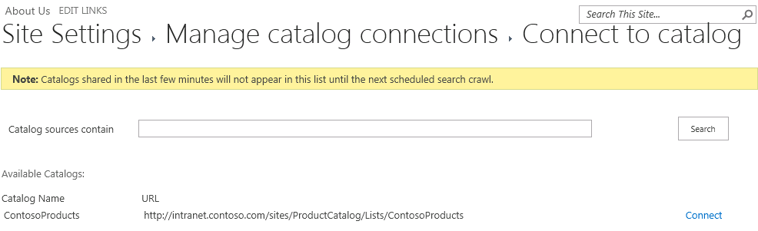

|  |
| --- |
| Description: note_dd**Note** |
| *If the catalog is not shown here, go back to the Search Service Application in Central Administration and restart a full index of the content source as shown in previous steps.* |

1. On the **Catalog Source Settings** page, select the following options and click **OK**:
   1. **Connection Integration:** Integrate the catalog into my site
   2. **Navigation Hierarchy:** 
      1. **Select column that categorizes items for navigation:** Item Category
      2. **Root term of hierarchy:** Electronics
   3. **Navigation Position:** Add to navigation root
   4. **Navigation Pinning:** Pin Terms to site navigation
   5. **Catalog Item URL Behavior:** Make URLs relative to this site
   6. **Catalog Item URL Format:**
      1. **Construct a URL format from catalog properties:** Checked
      2. **Primary Key Fields:** ItemId
   7. **Category Page:** Create a new page
   8. **Item Page:** Create a new page
2. Notice that after the page loads, the navigation is now reflecting not only the page manually created but also the items from the term set:

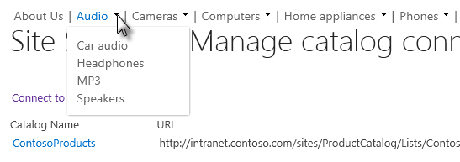

1. You can see the contents being pulled back automatically but selecting from the navigation **Computers 🡪 Laptops**:

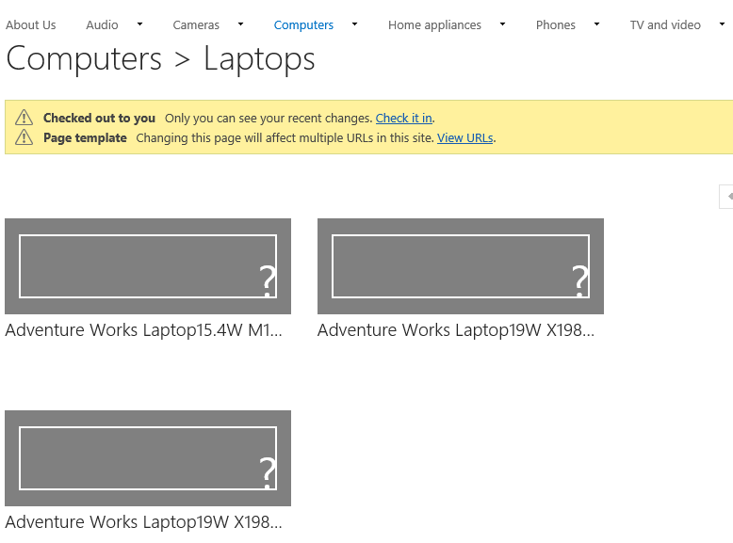

# Exercise 3: Customize Rollup and Detail Pages with the Content by Search Web Part

In this exercise you will customize the rollup and detail pages using the new Content by Search Web Part.

## Task 1: Create New Rollup Page Templates

When you connected the Publishing site to a catalog, SharePoint automatically created page layouts for use as the rollup and detail pages. In this task you will replace them with new ones.

Begin this task logged on to **SP** as **CONTOSO\Administrator**.

1. Using Internet Explorer, navigate to <http://intranet.contoso.com/sites/wcm>.
2. Using the gear icon in the top-right corner, select **Site Settings**.
3. Under the **Web Designer Galleries**, select **Master Pages and Page Layouts**.
4. Upload the file **ContosoRollup1Column.aspx** found in the **Assets\Page Layouts** in the location where the files for this demo are stored
5. When prompted, accept all default except the following fields:
   * **Content Type: Page Layout**
   * **Content Type Group:** Page Layout Content Types
   * **Content Type Name:** Catalog-Item Reuse
6. Repeat the steps above for **ContosoRollup2Columns.aspx**.
7. Using the gear icon in the top-right corner, select **View Site Contents**.
8. On the **Lists, Libraries, and other Apps** page, select the **Pages** library.
9. Using the ribbon, select the **Files** tab, click the down arrow on the **New Document** button and select **Catalog-Item Reuse**.

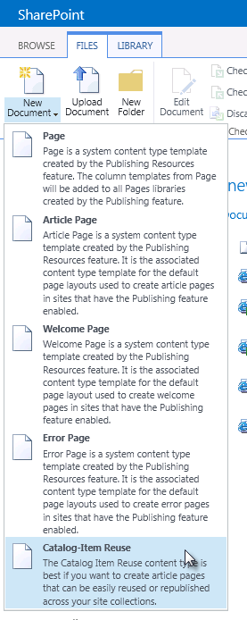

1. On the **Create Page** page, use the following to complete the form and click **Create**:
   * **Title:** Main Category
   * **URL Name:** MainCategory.aspx
   * **Page Layout:** (Catalog-Item Reuse) ContosoRollup1Column.aspx

## Task 2: Associate Category Pages with the new Rollup Page Template

In this task you will set the category notes to use the new rollup page you just created.

Begin this task logged on to **SP** as **CONTOSO\Administrator**.

1. Using Internet Explorer, navigate to <http://intranet.contoso.com/sites/wcm>.
2. Using the gear icon in the top-right corner, select **Site Settings**.
3. Under the **Site Administration** section, select **Term Store Management**.
4. Expand the **Site Collection – intranet.contoso.com-sites-wcm** node and the **Site Navigation** node.
5. Select the **Audio** node

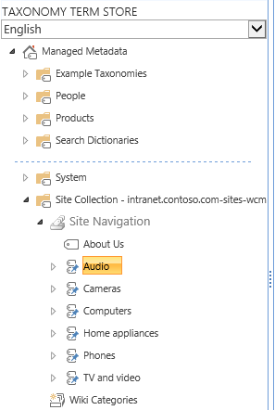

1. In the right-hand pane, select the **Navigation** tab.
2. Next, in the **Navigation Node Type** section, select **Term-Driven Page with Friendly URL**.

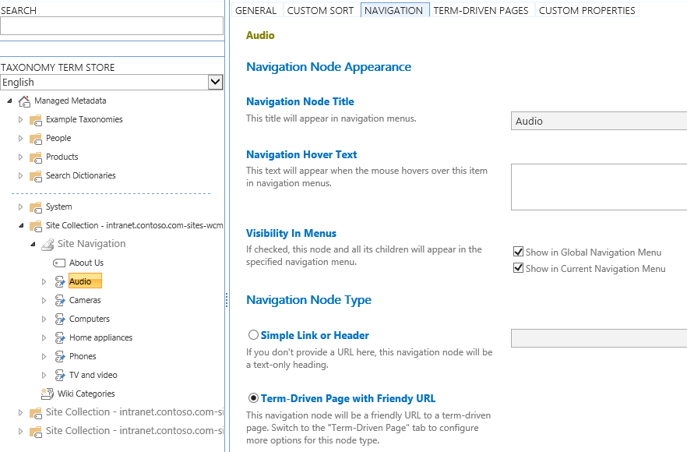

1. Then scroll to the bottom and click **Save**.
2. Next, select the **Term-Driven Pages** tab.
3. Under the **Target Page Settings**, check both of the following options and select the **/sites/wcm/Pages/MainCategory.aspx** page as the template to use:
   * Change target page for this term
   * Change target page for children of this term

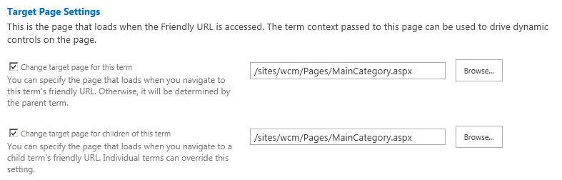

1. Scroll to the bottom and click **Save**.
2. Repeat these steps for the other top-level categories in the navigation: **Cameras**, **Computers**, **Home Appliances**, **Phones** and **TV and Video**.

## Task 3: Ensure the Content by Search Web Part is Available

In this task you will verify the Content by Search Web Part is available in this site collection.

Begin this task logged on to **SP** as **CONTOSO\Administrator**.

1. Using Internet Explorer, navigate to <http://intranet.contoso.com/sites/wcm>.
2. Using the gear icon in the top-right corner, select **Site Settings**.
3. Under the **Site Collection Administration** section, select **Site Collection Features**.
4. If the **SharePoint Server Enterprise Site Collection Features** feature is not activated, click the **Activate** button.

## Task 4: Customize the Main Category Page

In this task you will now customize the main category page you have created and configured to be used for the navigation rollup pages.

Begin this task logged on to **SP** as **CONTOSO\Administrator**.

1. Using Internet Explorer, navigate to <http://intranet.contoso.com/sites/wcm>.
2. In the top-navigation, select **Audio**.
3. The page should load with no content. Now you will modify the template all pages use to dynamically show content based on the URL of the page.

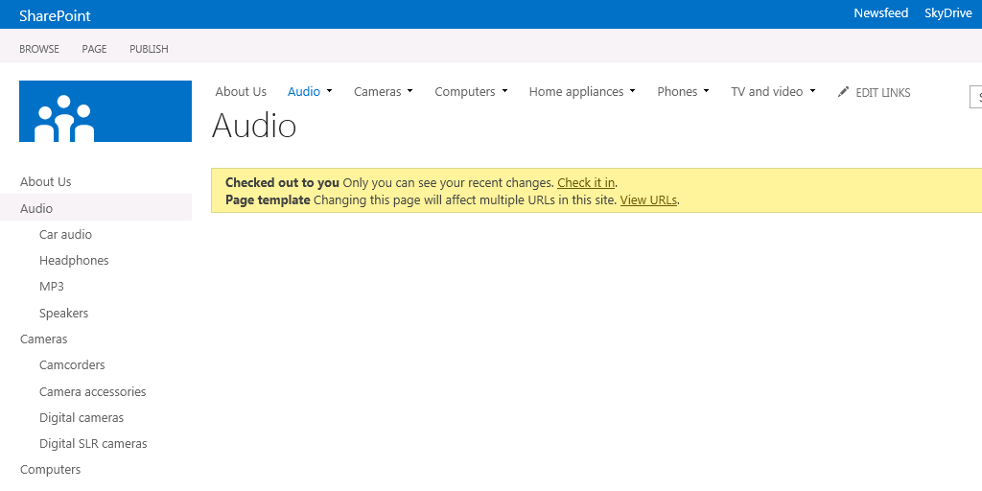

1. Using the gear icon in the top-right corner, select **Edit Page**.
2. When prompted, select **Edit Page Template**. It will warn you how many URLs will be affected by this change:

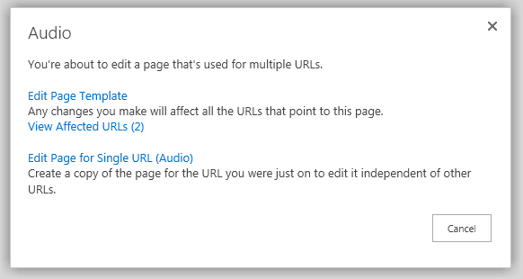

1. Click **Add a Web Part**.
2. From the **Content Rollup** category, select **Content Search** and click **Add**.

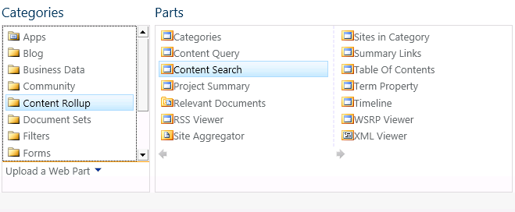

1. Select the Web Part that was added to the page and from the ribbon, select the Web Part contextual tab and then the Web Part Properties button:

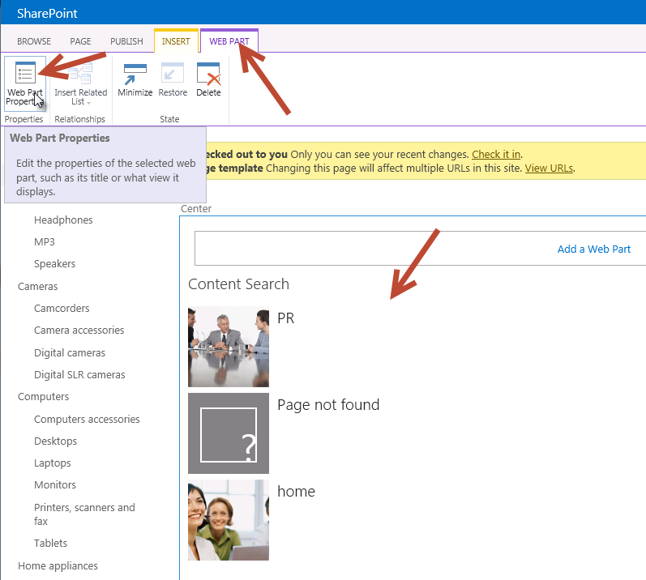

1. In the Editor Tool Pane on the right-hand side of the page, click the **Change Query** button under **Search Criteria**:

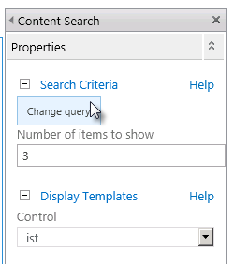

1. Use the following settings to filter the results & notice how the results change to the right of the page.
   * **Select a query:** ProductCatalog – ContosoProducts Results (Site Collection)
   * **Restrict by tag:** Restrict by current and child navigation terms

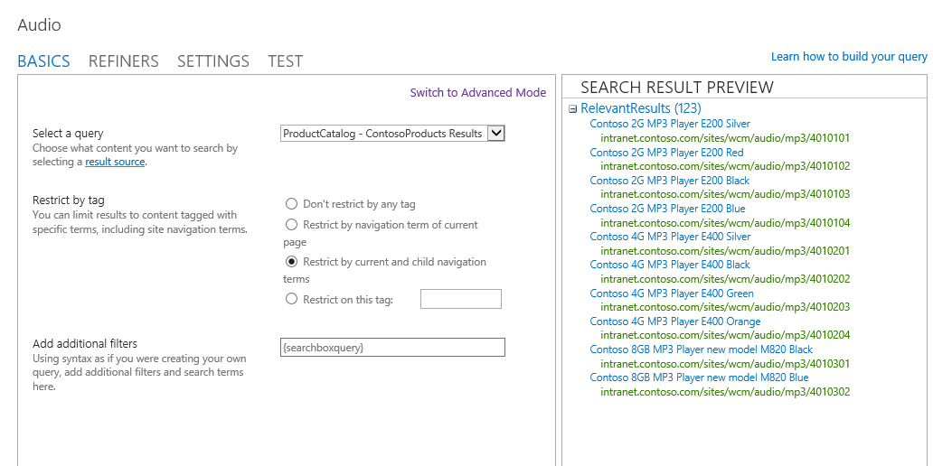

1. Click **OK** to close the query builder.
2. In the Editor Tool Pane, change the **Number of Items to Show** to be **9**, set the **Display Template** for **Item** to be **Picture on top, 3 lines on bottom** and click **OK** to apply all changes.
3. Finally, in the ribbon, click Check In to save the changes to the page to see the new rollup page:

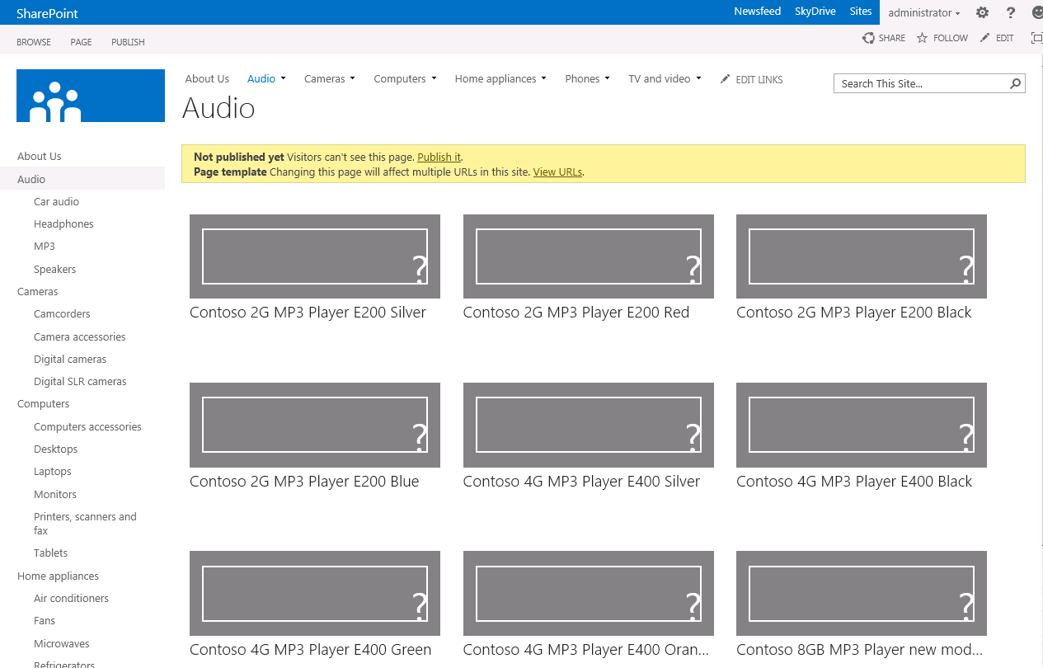

1. If you click on **Cameras**, you’ll notice it has the same changes applied to it.

# Exercise 4: Implement a Custom Brand with the Design Manager

In this task you will implement a custom brand in a SharePoint 2013 Publishing site with the new Design Manager.

## Task 1: Upload Design Assets

In this task you will upload the raw non-SharePoint design assets to the SharePoint site.

Begin this task logged on to **SP** as **CONTOSO\Administrator**.

1. Open Internet Explorer and navigate to <http://intranet.contoso.com/sites/wcm>.
2. Using the gear icon in the top-right corner, go to the **Site Settings** page.
3. Under the **Look and Feel** grouping, select the **Design Manager** link.
4. The Design Manager is a wizard-based experience. Not all steps are covered in this exercise. Jump to step 3, **Upload Design Files**, by clicking the link on the left-hand navigation.
5. Files can be manually uploaded or copied using a mapped folder. Before doing this, simplify the lab experience by turning off content approval, check in/out requirements and versioning on the Master Page Gallery:
   * In a new instance or tab of Internet Explorer, navigate to <http://intranet.contoso.com/sites/wcm>.
   * Using the gear icon in the top-right corner, go to the **Site Settings** page.
   * Under the **Web Designer Galleries** grouping, select the **Master Pages and Page Layouts** link.
   * Within the **Master Page Gallery**, use the ribbon to select the **Library** tab and click the **Library Settings** button.
   * On the library settings page select **Versioning Settings** from the **General Settings** column.
   * Change the following settings and click **OK**:
     1. **Content Approval:** No
     2. **Document Version History:** No Versioning
     3. **Require Checkout:** No
6. Map the Master Page Gallery location as a network drive from step 3 in the Design Manager:
   * Copy the URL listed in step 3 (<http://intranet.contoso.com/sites/wcm/_catalogs/masterpage>) to the clipboard.
   * Open **Windows Explorer** (Start 🡪 All Programs 🡪 Accessories 🡪 Windows Explorer).
   * Click **Computer** in the left-hand panel and then click the **Map Network Drive** label:

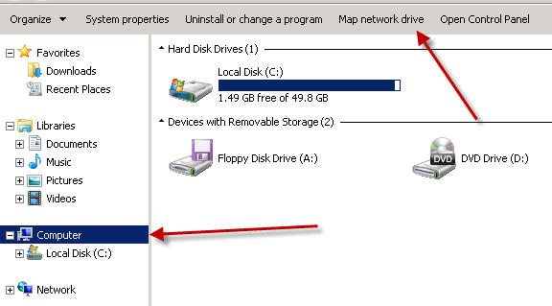

* + In the **Map Network Drive** dialog, click the link **Connect to a Web site that you can use to store your documents and pictures**.
  + In the **Add Network Location** dialog, click **Next**.
  + Click **Choose a custom network location** and click **Next**.
  + Paste the URL of the **Master Page Gallery** and click **Next**. You may be prompted to login to confirm you can access the folder:

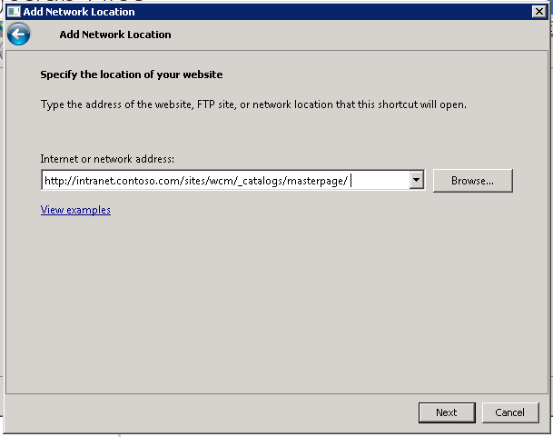

* + When prompted, accept the default name of the location and click **Next** & finally **Finish** to complete the wizard.

1. With a mapped folder created for the Master Page Gallery, copy all the contents from the **DesignManager** folder included with the student files in this lab into the Master Page Gallery.

## Task 2: Convert the HTML Master Page to a SharePoint Master Page

In this task you will convert one of the files you uploaded in the previous step to a SharePoint master page.

Begin this task logged on to **SP** as **CONTOSO\Administrator**.

1. In the **Design Manager**, click on step 4: **Edit Master Pages**.
2. The **Design Manager: Edit Master Pages** page will show all master pages in the Master Page Gallery. You need to convert your HTML file that was previously uploaded to a SharePoint master page. **Click the Convert an existing HTML master page** link.
3. Select the **ContosoMasterDesign.html** file and click **Insert**. Make sure you select the row and don’t click on the actual file link as clicking the link will take you to that file.
4. Accept and/or click through any a prompts you receive and refresh the page until you see the **ContosoMasterDesign** show up on the page with a status of **Conversion successful**.

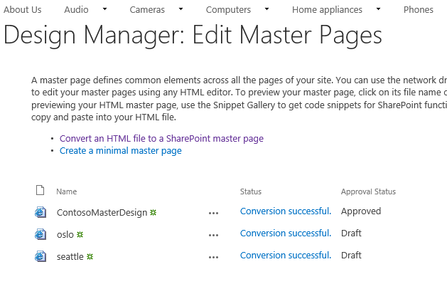

1. Click the **Conversion successful** link for the **ContosoMasterDesign** to open the preview page.

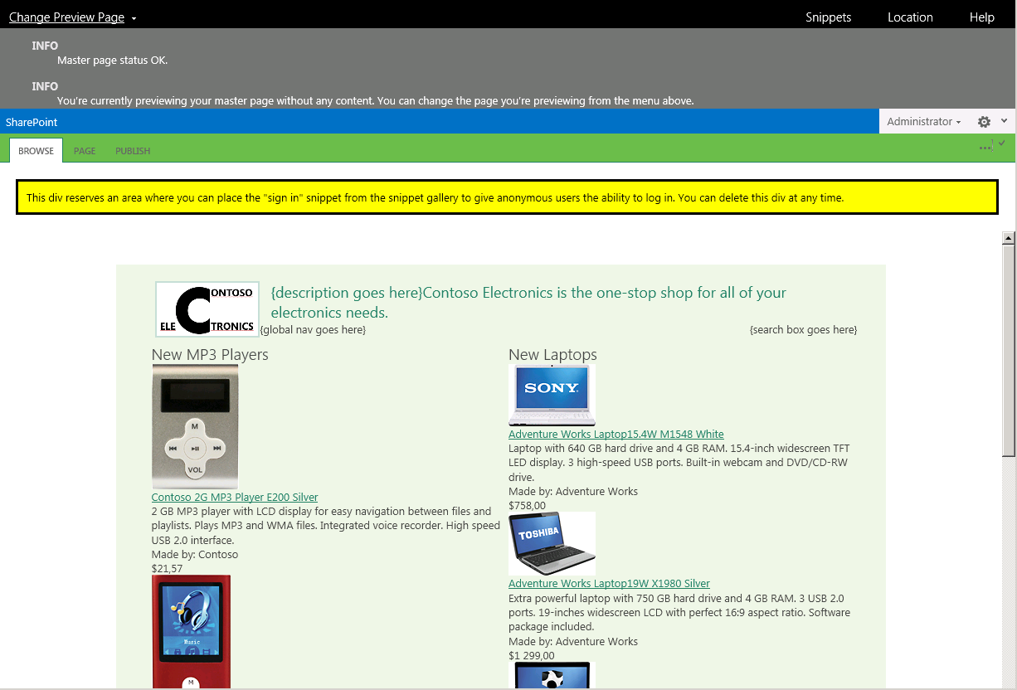

## Task 3: Customize and Preview the SharePoint Master Page in Notepad

In this task you will customize and preview the changes to your master page in a tool that knows nothing about SharePoint: notepad.

Begin this task logged on to **SP** as **CONTOSO\Administrator**.

1. Open **Notepad** (**Start 🡪 All Programs 🡪 Accessories 🡪 Notepad**) and open the **ContosoMasterDesign.html** file from the mapped network drive. Ensure you don’t open the \*.master version of this file… only the \*.html version.
2. Search for the text **{description goes here}** (around line **124** using the **CTRL+G** shortcut) and add the following code below and save your changes:

<h1>Hello World</h1>

1. Go back to the browser that has the preview open and refresh the page using Ctrl + F5 to see the changes immediately take effect:

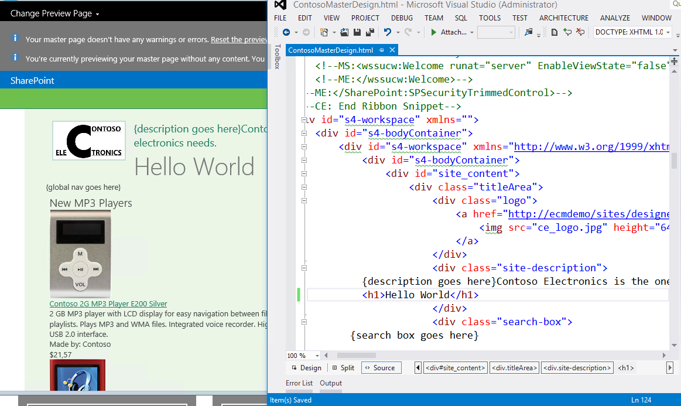

1. That simple change was just to show how the preview experience works. Remove the line you just added and save the HTML file.
2. Add in global navigation for the site using the Snippet Gallery:
   * In the master page preview, click the **Snippets** link in the top-right of the page to launch the Snippet Gallery.
   * In the **Snippet Gallery**, select the **Top Navigation** button from the **Design** tab in the ribbon. In the Customization – Top Navigation section, change **AdjustForShowStartingNode** to True, and **StaticDisplayLevels** to 1. Click Update to preview the changes.

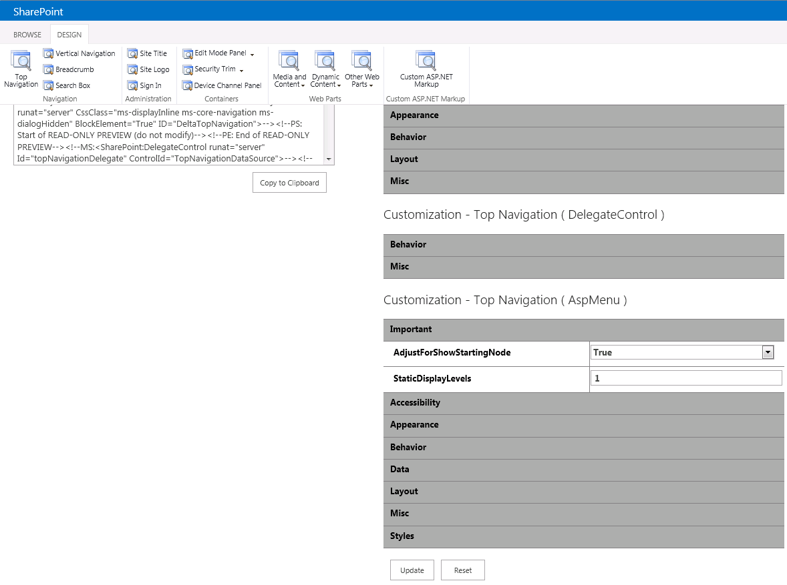

* + Click the **Copy to Clipboard** button under the **HTML Snippet** to copy the HTML generated by the Snippet Gallery.
  + Go back to Notepad and replace the following text with the HTML you copied to the clipboard and save your changes:

{global nav goes here}

* + Go back to the master page preview and refresh the page using Ctrl + F5. You should now see the live navigation being added to the page:

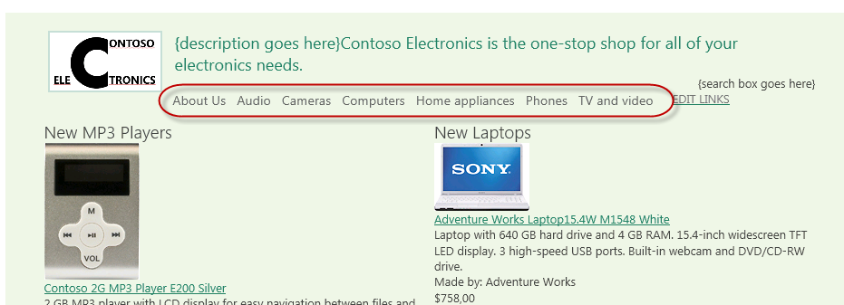

1. Add the search box to the master page.
   * Jump back to the **Snippet Gallery**.
   * Click the **Search Box** button in the Design tab of the ribbon.
   * Click the **Copy to Clipboard** button under the **HTML Snippet** to copy the HTML generated by the Snippet Gallery.
   * Go back to Notepad and replace the following text with the HTML you copied to the clipboard and save your changes:

{search box goes here}

1. Go back to the master page preview and refresh the page. You should now see the live search box being added to the page:

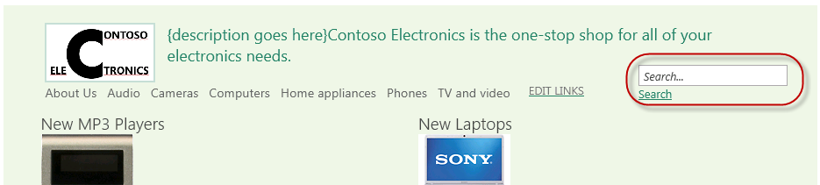

1. Lastly, move the ContentPlaceholderMain control into the area where the rendered content should appear.
   * In Notepad, find the following HTML comment in the master page:

<!--end title area-->

* + Immediately following that title you will see a **<DIV>** followed by a **<TABLE>**. The **<TABLE>** contains the static content used in the designer generated master page. Delete this entire table (it starts around line 139 and goes to around line 291).
  + Jump to the bottom of the master page source. You should a block of HTML that starts with the following markup:

<div name="ContentPlaceHolderMain">

* + Select the entire **<DIV>** and its contents and paste it where the **<TABLE>** was that you just removed.
  + Finally, look for HTML within the <DIV> you just moved that starts with this:

<div class="DefaultContentBlock" style="border:medium black solid; background:yellow; color:black; margin:20px; padding:10px;">

This div, which you should delete, represents the content area that your Page Layouts and pages will fill. Design your Master Page around this content placeholder.

</div>

* + Delete the markup listed above. This was added by SharePoint to highlight where your dynamic content should appear.
  + Save your changes.

1. Go back to the master page preview and refresh the page using Ctrl + F5. You should no longer see the static content:

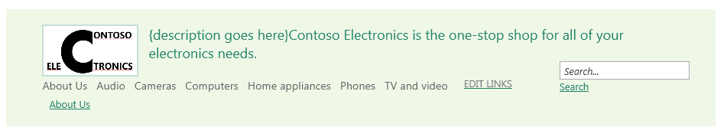

## Task 4: Set the Publishing Site to Use the New Master Page

In this task you will configure the Publishing site to use the new master page you have created.

Begin this task logged on to **SP** as **CONTOSO\Administrator**.

1. Open Internet Explorer and navigate to the Publishing site at <http://intranet.contoso.com/sites/wcm>.
2. Use the gear icon in the top-right corner of the page to jump to the **Site Settings** page.
3. Under the **Look and Feel** grouping, select **Master Page**.
4. Change the **Site Master Page** to **ContosoMasterDesign** and click **OK**.
5. Go back to the homepage of the site to see how your master page is now being used as the site master page. You can also click on the links in the navigation to view how the rollup pages appear.

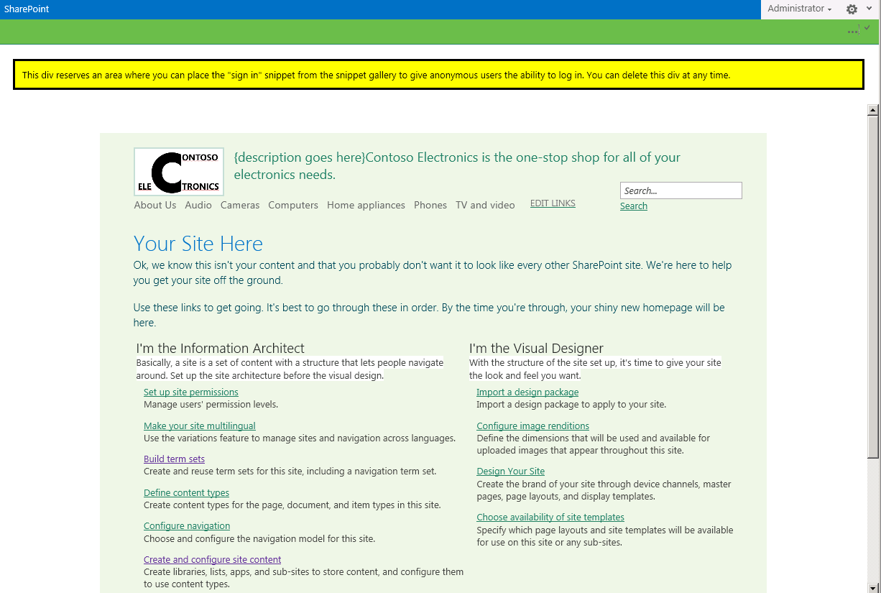

* This is the end of the lab

# Lab Summary

Summary on what where the tasks that we did.

Setup a taxonomy, content catalog and site with sample content

Publishing & connecting to a content catalog

Configuring a site for managed navigation

Implementing a custom brand